**Exercise 1: Setting Up JUnit**

Scenario: You need to set up JUnit in your Java project to start writing unit tests.

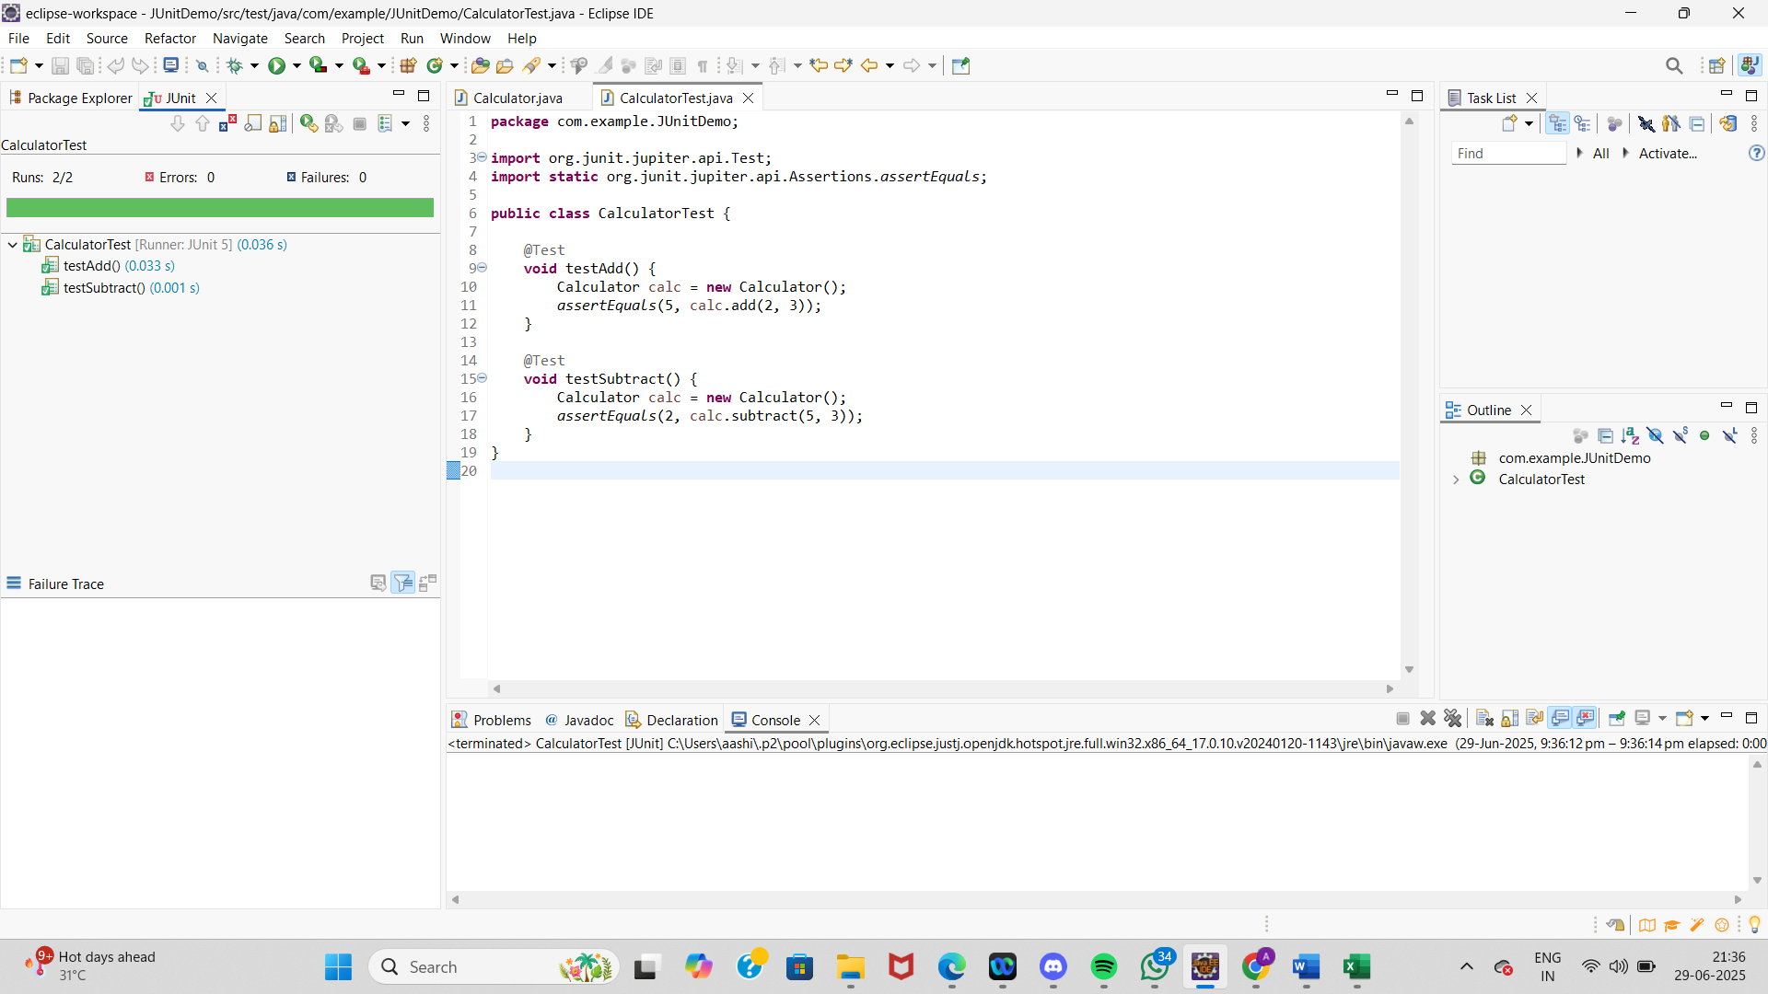

**Calculator**  
  
package com.example.JUnitDemo;

public class Calculator {

public int add(int a, int b) {

return a + b;

}

public int subtract(int a, int b) {

return a - b;

}

}

**CalculatorTest**

package com.example.JUnitDemo;

import org.junit.jupiter.api.Test;

import static org.junit.jupiter.api.Assertions.assertEquals;

public class CalculatorTest {

@Test

void testAdd() {

Calculator calc = new Calculator();

assertEquals(5, calc.add(2, 3));

}

@Test

void testSubtract() {

Calculator calc = new Calculator();

assertEquals(2, calc.subtract(5, 3));

}

}

**Exercise 3: Assertions in JUnit**

Scenario: You need to use different assertions in JUnit to validate your test results.

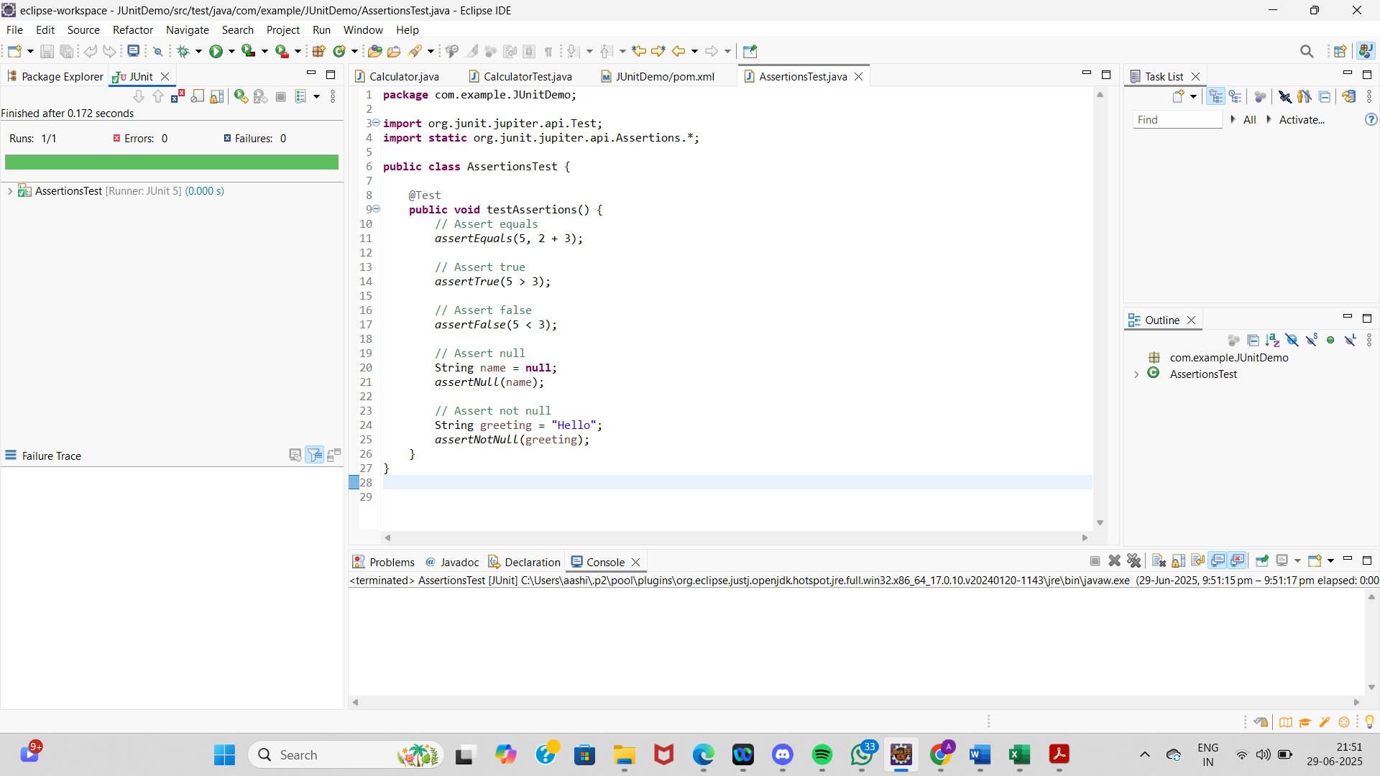

**AssertionsTest.java**

package com.example.JUnitDemo;

import org.junit.jupiter.api.Test;

import static org.junit.jupiter.api.Assertions.*;

public class AssertionsTest {

@Test

public void testAssertions() {

// Assert equals

assertEquals(5, 2 + 3);

// Assert true

assertTrue(5 > 3);

// Assert false

assertFalse(5 < 3);

// Assert null

String name = null;

assertNull(name);

// Assert not null

String greeting = "Hello";

assertNotNull(greeting);

}

}

**Exercise 4: Arrange-Act-Assert (AAA) Pattern, Test Fixtures, Setup and Teardown Methods in JUnit**

Scenario: You need to organize your test

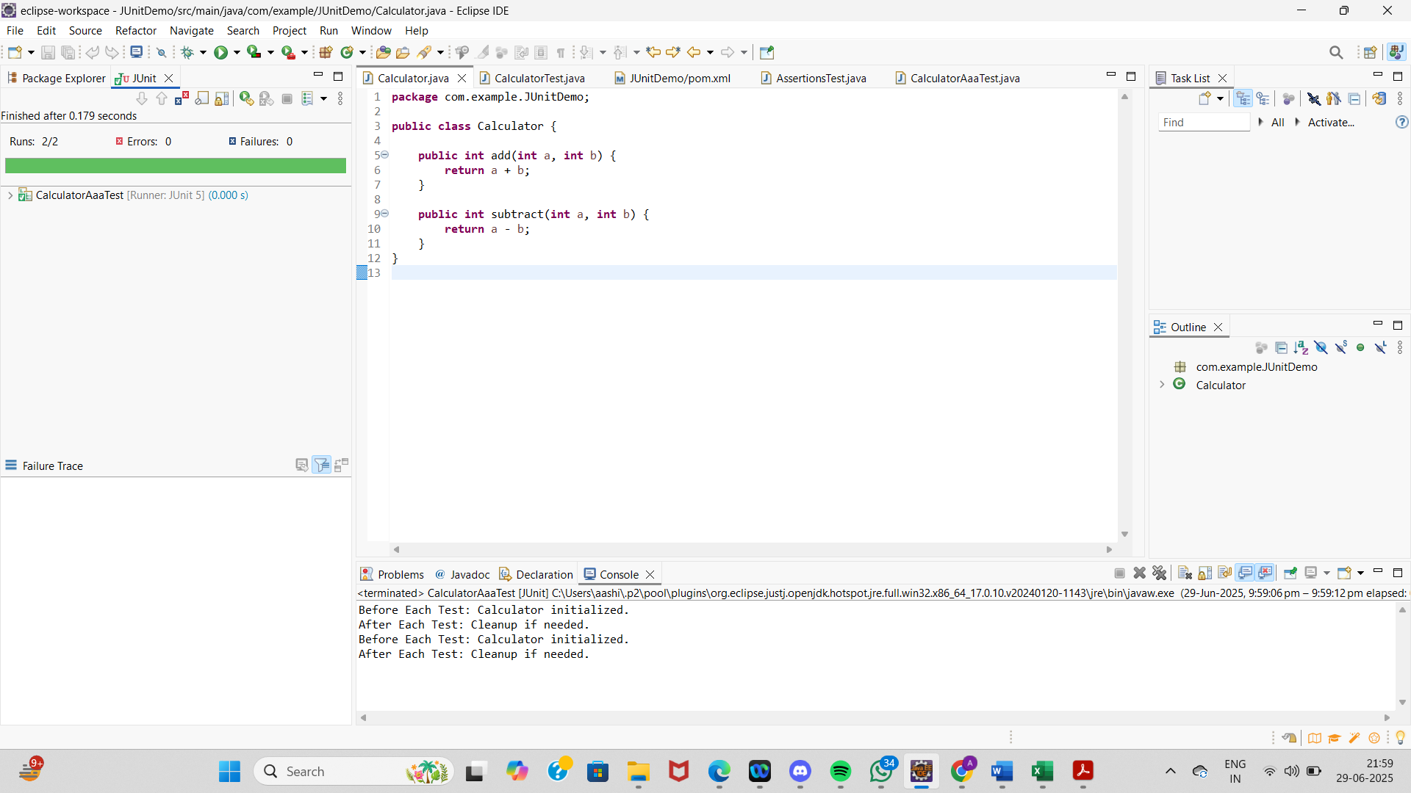

**CalculatorAaaTest.java**

package com.example.JUnitDemo;

import org.junit.jupiter.api.BeforeEach;

import org.junit.jupiter.api.AfterEach;

import org.junit.jupiter.api.Test;

import static org.junit.jupiter.api.Assertions.*;

public class CalculatorAaaTest {

private Calculator calculator;

// Setup method: runs before each @Test

@BeforeEach

void setUp() {

calculator = new Calculator();

System.out.println("Before Each Test: Calculator initialized.");

}

// Teardown method: runs after each @Test

@AfterEach

void tearDown() {

System.out.println("After Each Test: Cleanup if needed.");

}

@Test

void testAddition() {

// Arrange

int a = 2;

int b = 3;

// Act

int result = calculator.add(a, b);

// Assert

assertEquals(5, result);

}

@Test

void testSubtraction() {

// Arrange

int a = 5;

int b = 3;

// Act

int result = calculator.subtract(a, b);

// Assert

assertEquals(2, result);

}

}

**Calculator.java**

package com.example.JUnitDemo;

public class Calculator {

public int add(int a, int b) {

return a + b;

}

public int subtract(int a, int b) {

return a - b;

}

}